Technische Universität München

Department of Mechanical Engineering

Institute of Automation and Information Systems

Prof. Dr.-Ing. Birgit Vogel-Heuser

Bachelorarbeit

Dynamic Generation of Modular Industrial Plant Visualizations on a Manufacturing Execution System (MES) Interface



|  |  |
| --- | --- |
| Author: | Miguel Romero Karam |
| Advisor: | Dr.-Ing. Daniel Schütz |
| Supervisor: | Emanuel Trunzer, M.Sc. |
| Begin Date: | 15 April 2018 |
| Submission Date: | 15 Oktober 2018 |

Statutory Declaration

I hereby confirm to have written the present dissertation independently and only with the use of the sources and resources I have indicated. Both content and literal content were identified as such. The work has not been available in this or similar form to any other panel of examiners.



Date: Signature:

Abstract

…

Kurzzusammenfassung

…

Index

Statutory Declaration III

Abstract V

Index VII

List of Figures X

No table of figures entries found. X

List of Tables XII

No table of figures entries found. XII

Abbreviations XIV

1 Introduction 1

1.1 Overview and Motivation 1

1.2 Problem Definition 1

1.3 Initial Situation 2

1.4 Aim of the Bachelor Thesis 2

1.5 Composition of the Bachelor Thesis 2

1.5.1 GIST Project Management 2

1.5.2 Agile Development Methodology 2

2 Technological Standpoint 2

2.1 Industrial Control in General 2

2.1.1 Definitions 2

2.1.2 Historical Industrial Context 2

2.1.3 Current Trends 2

2.1.4 Areas of Application 3

2.2 Industrial Process Control 3

2.2.1 Classification of Industrial Processes 3

2.2.2 Process Control System (PCS) 3

2.2.3 Plant Hierarchy Model (ISA-95) 4

2.2.4 Process Visualizations 4

2.2.5 Piping and Instrumentation Diagram (P&ID) 5

2.2.5.1 Definition 5

2.2.5.2 Functions 5

2.2.5.3 Advantages 5

2.2.5.4 Disadvantages 5

2.3 Manufacturing Execution Systems 5

2.3.1 Overview (Automatisierungspyramid -> decentral Network) 5

2.3.2 Functions 5

2.3.3 MES in Context of the 4th Industrial Revolution 5

2.3.4 Overview of Legato Sapient® 5

2.3.4.1 Design 5

2.3.4.2 Features 6

2.3.4.3 Software Architecture 6

3 P&ID Shapes Library 8

3.1 Overview 8

3.1.1 Graph Theory 8

3.1.1.1 What is a graph? 8

3.1.1.2 Graph Visualizations 8

3.1.1.3 Graph Interaction 8

3.1.1.4 Graph Layouts 8

3.1.1.5 Graph Analysis 8

3.1.1.6 8

3.2 mxGraph API 8

3.3 8

3.3.1 Core Architecture 8

3.3.1.1 mxGraph Model 9

3.3.1.2 Transaction Model 9

3.3.1.3 mxCell 9

3.3.1.3.1 Styles 9

3.3.1.3.2 Geometry 9

3.3.1.3.3 User Objects 9

3.3.1.3.4 Cell Types 9

3.3.1.4 Group Structure 9

3.3.2 Technologies 9

3.3.2.1 Deployment 9

3.3.2.2 mxGraph Technologies 9

3.3.2.3 9

3.3.3 Schema 9

3.4 10

4 Legato Sapient® Boardlet 12

4.1 Overview of Software Architecture 12

4.2 Design 12

4.2.1 User Interface (UI) 12

4.2.2 User Experience (UX) 12

4.3 Business Logic 13

4.3.1 Overview 13

4.3.2 Presentation Logic 13

4.3.3 Database Queries 13

4.3.3.1 PostgreSQL Queries 13

4.3.3.2 Get Data Generic Function via getRecords() 13

4.3.3.3 Waiting for Asynchronous Requests to Complete 13

4.3.4 Object Relational Data Mapping 13

4.3.4.1 Nodes to Vertex Shapes (E, I, A, G) 13

4.3.4.2 Connections to Edge Shapes (L) 14

4.3.5 Graph Layout Algorithm 14

4.3.5.1 Build Hierarchy 14

4.3.5.2 Hierarchy Traversal 14

4.3.5.3 Vertex Placement 14

4.3.6 Generation of the XML File 15

4.3.6.1 Structure of XML File 15

4.3.6.2 Recursive Instantiation 15

5 Testing, Verification and Validation 17

5.1 Prototypical Implementation in an Industrial Context 17

6 Synopsis 19

List of Figures

**No table of figures entries found.**

List of Tables

Abbreviations

|  |  |
| --- | --- |
| Abbreviation | Description |
|  |  |
| API | Application Programming Interface |
| GUI | Graphical User Interface |
|  |  |
| MES | Manufacturing Execution System |
| ProcAppCom | Process Application Composer |
| PCS | Process Control System |
|  |  |

1. Introduction
   1. Overview and Motivation

The ProcAppCom (Process Application Composer) research project behind this bachelor thesis represents a cooperation between multiple industrial partners, namely 3S-Smart Software Solutions GmbH, Gefasoft GmbH, Johann Albrecht Brautechnik GmbH and APE Engineering GmbH with the Technical University of Munich. The main objective of the ProcAppCom research project is the automatic configuration and generation of control code and visualizations for production plants in the field of process engineering.

Gefasoft GmbH is a leading and innovative provider of production-related software solutions. With the product Legato Sapient® Gefasoft offers a completely web-based production control system (MES) for the cross-plant evaluation of messages, measured values ​​and key figures, amongst other industry key functionalities.

At present, the development of control software and visualization interfaces for the operation of smaller process engineering systems, as well as their connection to Manufacturing Execution Systems (MES), are extremely costly. Because of this, creating (or later modifying) plant-specific visualization interfaces is one of the cost and cost drivers of such projects. Motivation of this bachelor thesis is a concept for the visualization of convertible process plants in order to reduce costs and / or expenditure with the implementation of MES, so that any enterprises can dispose of and profit from these software solutions. In general, the dynamic composition of GUIs based on visualization components.

* 1. Problem Definition

Today's trends and demands on production technology lead to a permanent increase in the complexity of industrial production facilities and to permanent technical changes that propagate throughout documentation, . This signifies an important the engineering, operation and adjustments of production control systems (MES) and leads to the fact that its connection and configuration must be individually configured and manually adjusted, with the creation and modification of plant-specific visualization interfaces (GUI) a significant cost or cost driver is.

* 1. Initial Situation

The foundations of this project have been laid by various other projects at Gefasoft in the context of the ProcAppCom research project. A projection model and description model for process engineering plants was initially developed. Before the start of this project, it was also possible for plant models to be read and transcribed directly to database tables of the MES Legato Sapient®. Additionally, it was possible to dynamically generate factory edge gateways for the data-related connection of the control of systems to the MES. The dynamic visualization generation represents the last part of this research project.

<INSERT GLOBAL ProcAppCom PROJECT ARCHITECTURE/CONCEPT SHOWING ALL PUZZLE PIECES, ASK DANIEL FOR PHOTO>

* 1. Aim of the Bachelor Thesis

Aims:

* Reduction of effort and acceleration of development and adaptation of visualization generation of industrial processes.
* Uniform and modular design of the visualization components for generating clear, standard-defined visualization interfaces at the process control level for monitoring the process variables.
* Integration of the software solution in the MES Legato Sapient®.

Requirements:

* INSERT ANFORDERUNGSLISTE HIER

Main Tasks / Milestones

* 1. Composition of the Bachelor Thesis
     1. GIST Project Management

Why you should drop down project management MEDIUM.

* + 1. Agile Development Methodology

Agile Development Cycles

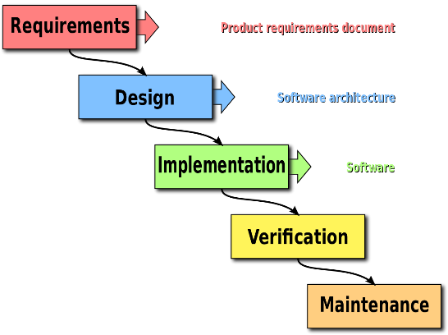

1. Technological Standpoint
   1. Industrial Control in General
      1. Definitions

* Model
* Technical Process
* Tech. System AT23,
* Relationship Diagram AT24

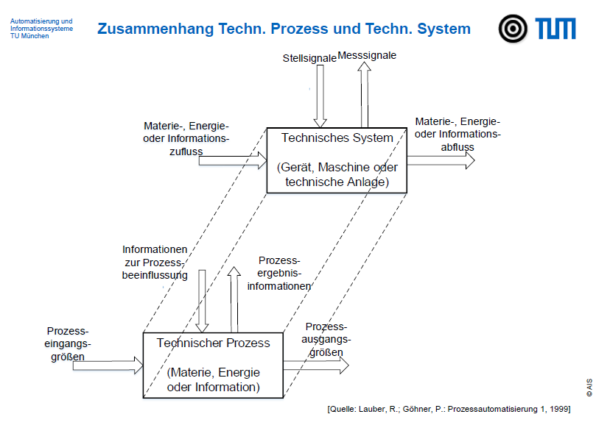

* + 1. Historical Industrial Context
    2. Current Trends
    3. Areas of Application

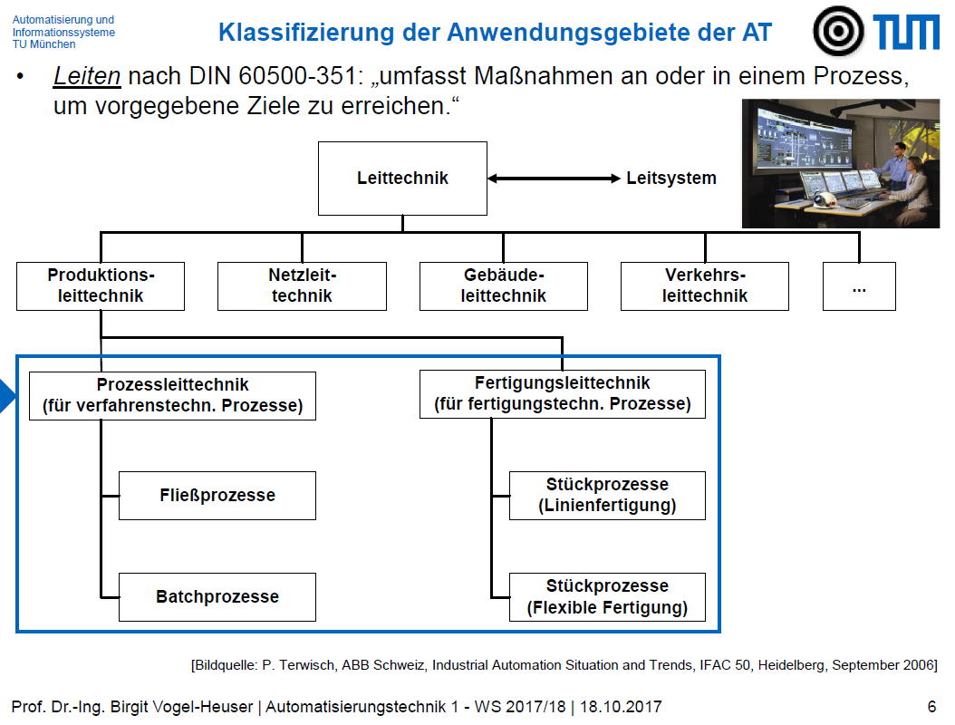

* 1. Industrial Process Control
     1. Classification of Industrial Processes

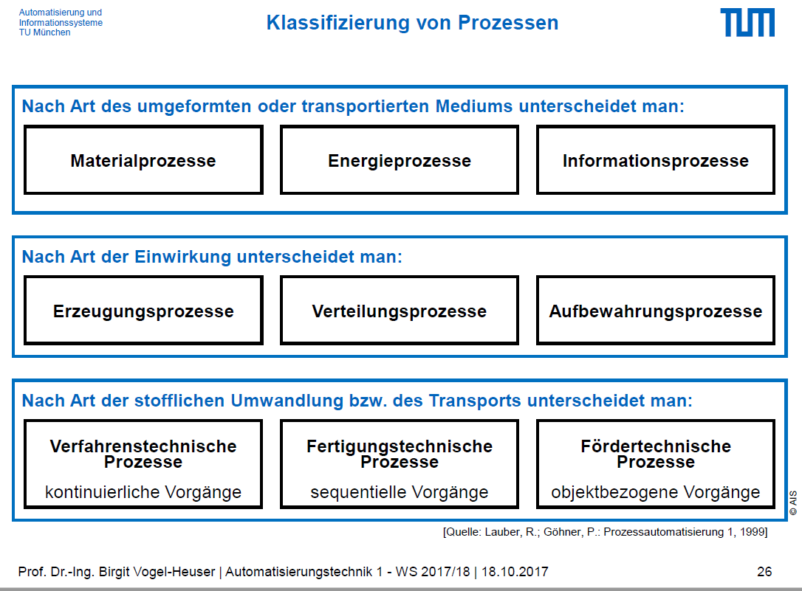

* + 1. Process Control System (PCS)

Definiton

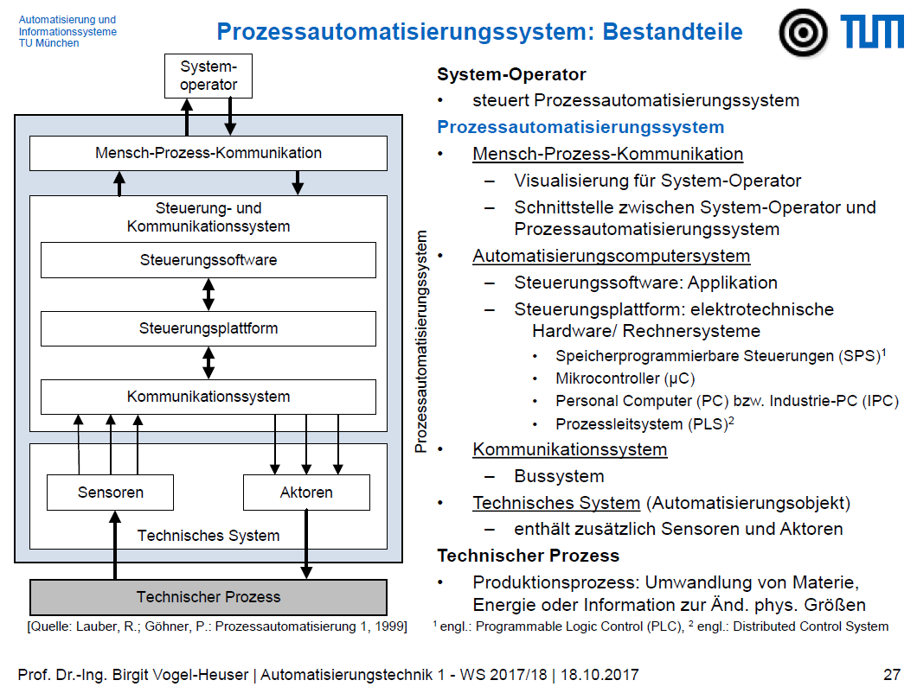

* + 1. Plant Hierarchy Model (ISA-95)

[ISA-95](https://en.wikipedia.org/wiki/ISA-95) as it is more commonly referred, is an international standard for developing an automated interface between enterprise and control systems.

(<https://en.wikipedia.org/wiki/Enterprise_control#ISA95_.E2.80.9Clevels.E2.80.9D_for_enterprise_integration>)

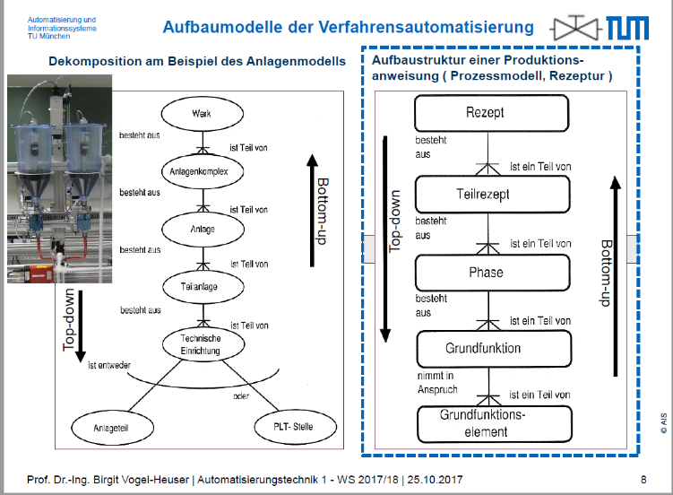

* + 1. Process Visualizations

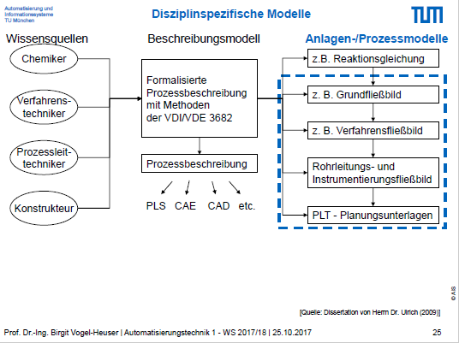 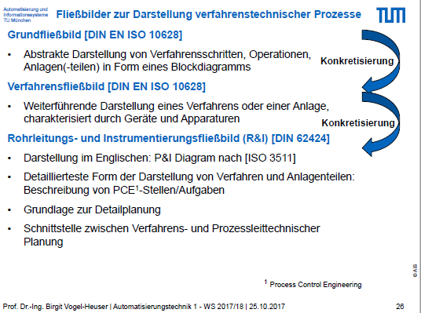

* + 1. Piping and Instrumentation Diagram (P&ID)
       1. Definition
       2. Functions
       3. Advantages
       4. Disadvantages
  1. Manufacturing Execution Systems
     1. Overview (Automatisierungspyramid -> decentral Network)
     2. Functions
     3. MES in Context of the 4th Industrial Revolution
     4. Overview of Legato Sapient®

Entirely Web-based architecture and modular and customizable to the core to keep of with requirements.

* + - 1. Design

Component based, modular design of dashboards (easy creation by adding boardlets)

Dashboard > Boardlet > Ember Components

* + - 1. Features
      2. Software Architecture

1. P&ID Shapes Library
   1. Overview
      1. Graph Theory
         1. What is a graph?
         2. Graph Visualizations
         3. Graph Interaction
         4. Graph Layouts
         5. Graph Analysis
   2. mxGraph API

<INSERT Overview FROM 1.1 and Basic Licenscing Info FROM 1.5 and javascript client side working principles FROM 2.2 FROM mxGraph Javascript User Manual>

* 1. 1. Core Architecture

<INSERT mxGraph API Diagrams globales (class diagram)>

* + - 1. mxGraph Model
      2. Transaction Model
      3. mxCell
         1. Styles
         2. Geometry
         3. User Objects
         4. Cell Types
      4. Group Structure
    1. Technologies
       1. Deployment

<INSERT HIGHLIGHTS FROM 1.3 mxGraph Javascript User Manual>

* + - 1. mxGraph Technologies

<INSERT HIGHLIGHTS FROM 1.4 mxGraph Javascript User Manual>

* + 1. Schema

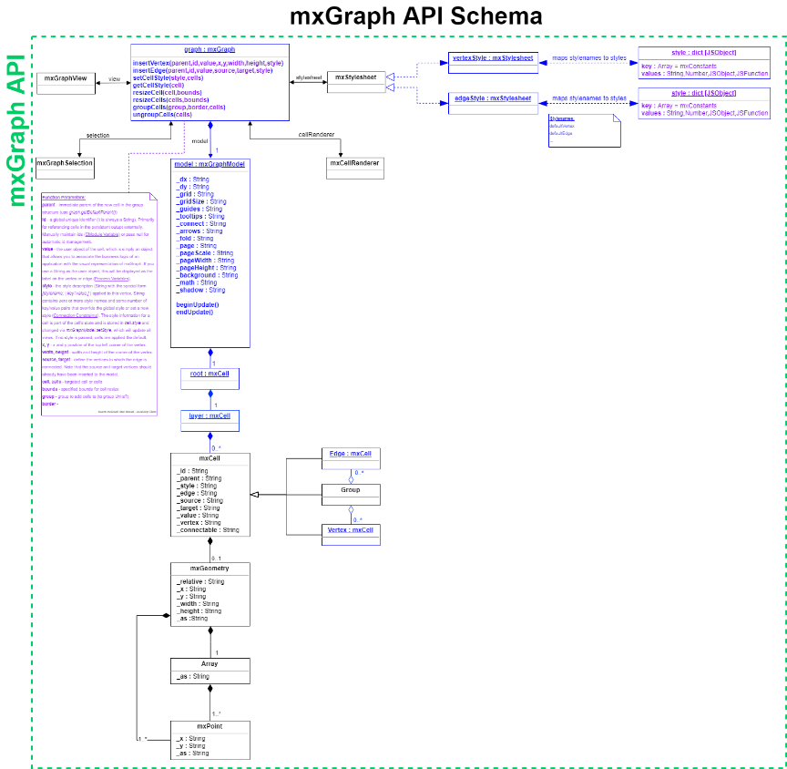



1. Legato Sapient® Boardlet
   1. Overview of Software Architecture

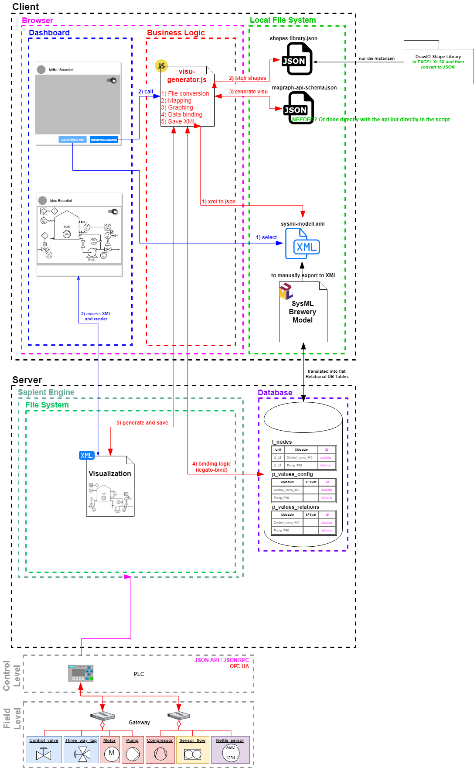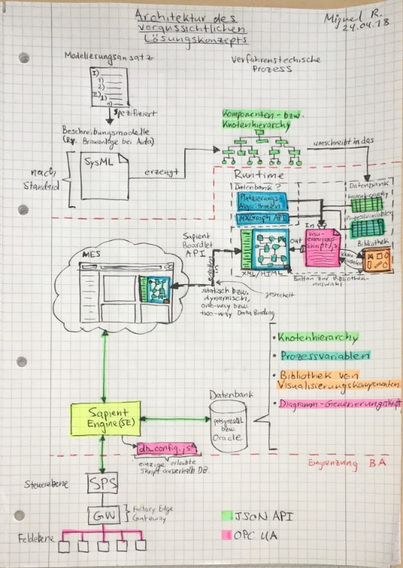

Agreturar datenbank y SE connectiongar modelierungsansatz y knotenbaum y reestrucRequirements

* 1. Design

<INSERT PHOT OF P&ID VISUALIZER DASHBOARD WITH ALL BOARDLETS, SQUARE ON THE P&ID CREATOR BOARDLET AND SQUARE ON INDIVIDUAL EMBER COMPONENTS? OR TOO UNUBERSICHTLICH >

Modular Component-based solution. All included, up and ready boardlet.

* + 1. User Interface (UI)
    2. User Experience (UX)
  1. Business Logic
     1. Overview

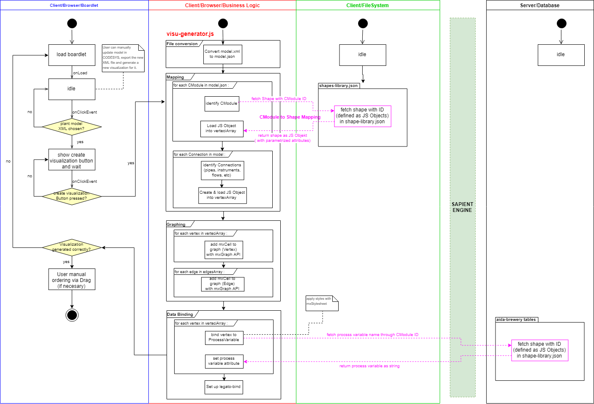

* + 1. Presentation Logic
    2. Database Queries
       1. PostgreSQL Queries
       2. Get Data Generic Function via getRecords()
       3. Waiting for Asynchronous Requests to Complete

Asynchronous

* + 1. Object Relational Data Mapping
       1. Nodes to Vertex Shapes (E, I, A, G)
       2. Connections to Edge Shapes (L)

Only process_flows are modelled in model, so business logic to determine the line shapes accordingly.

ROBUST SET OF RULES

P&ID Line Shapes:

P - pipe_line

C – connection_line

S – signal_line

D – data_line

|  |  |  |  |  |  |
| --- | --- | --- | --- | --- | --- |
| **Source\Target** | **Equipment** | **Instrument** | **Group** | **Arrow** | **Line** |
| **Equipment** | P | P (*) | P (**) |  | - |
| **Instrument** | P (*) | D | D (**) |  | (*) |
| **Group** | P (**) | D (**) | P (***) |  | - |
| **Arrow** |  |  |  |  |  |
| **Line** | - | (*) | - |  | - |

Special Cases:

* if Equipment to Instrument to Equipment (Instrument between 2 equipment, short circuit Equipment to Equipment with one single pipe_line and connect instrument to that pipe_line with a connection_line.

** if group to anything or anything to group, connect to group border, but if outermost group, then create a new arrow and connect to this arrow (attention to arrow direction).

*** use ports so that lines are continuous and don’t appear to break on group borders

* + 1. Graph Layout Algorithm
       1. Build Hierarchy
       2. Hierarchy Traversal

Pathfinder in form of posrt-order depth-first search to find ordered path of node visited while traversing hierarchy.

* + - 1. Vertex Placement
* Overview
* Settings

Settings implemented as parameters allow for fine tuning of the algorithm.

<INSERT Table with list of settings>

* Fine Tuning of Parameters
  + 1. Generation of the XML File
       1. Structure of XML File
       2. Recursive Instantiation

1. Testing, Verification and Validation
   1. Prototypical Implementation in an Industrial Context

For Comercial Deployment and Industrial Application

1. Synopsis